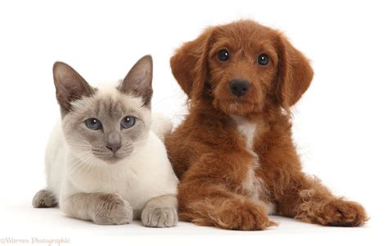
Help US Help Them! Don’t leave them out in the Cold!
THE PROBLEM: The Region of Durham has a big problem with pet overpopulation.
SNIP is the Solution
By spaying or neutering your pet, you’ll help control the pet homelessness crisis. Every day there are many ads for fostering kittens, cats, dogs, and puppies. Thanks to Covid-19, the “Pandemic Pets” are being abandoned and returned to shelters at an alarming rate. The stats are concerning – too many unwanted, unloved pets…and that was BEFORE Covid….
Spay Neuter Initiatives Association (a CRA Registered Charity) is looking to the future where pet overpopulation will be a thing of the past. Our Project goal is to bring an affordable Spay Neuter Clinic to the Durham Region whereby rescue groups, students, seniors, and low-income pet owners can take their animals for quality care at a reasonable rate instead of traveling hours outside the region for similar care.

Spay Neuter Initiatives Project has recently been offered an amazing opportunity to lease a property in Port Perry located right in the center of Durham Region which will include a much-needed Low-Cost Spay/Neuter Clinic.
We are asking donors to help us take advantage of this opportunity. With your help, we can do this! With your help, we can finally offer all of the animals in the Region and beyond the safe and affordable Spay/Neuter procedures they need. And we can begin to solve the never-ending problem of abandoned and unwanted cats and dogs in our Region.
The Plan is in place BUT we need your help with start-up funds to make this project a reality!
Every dollar makes a Difference! Tax Receipts will be issued for donations over $20.00.
https://www.canadahelps.org/en/charities/spay-neuter-initiatives-association/
https://www.gofundme.com/manage/the-spay-neuter-initiative-in-durham-region
https://www.facebook.com/SpayNeuterInitiatives
Registered Name: Spay Neuter Initiatives Association
Business No: 855146312RR0001 CRA REGISTERED

